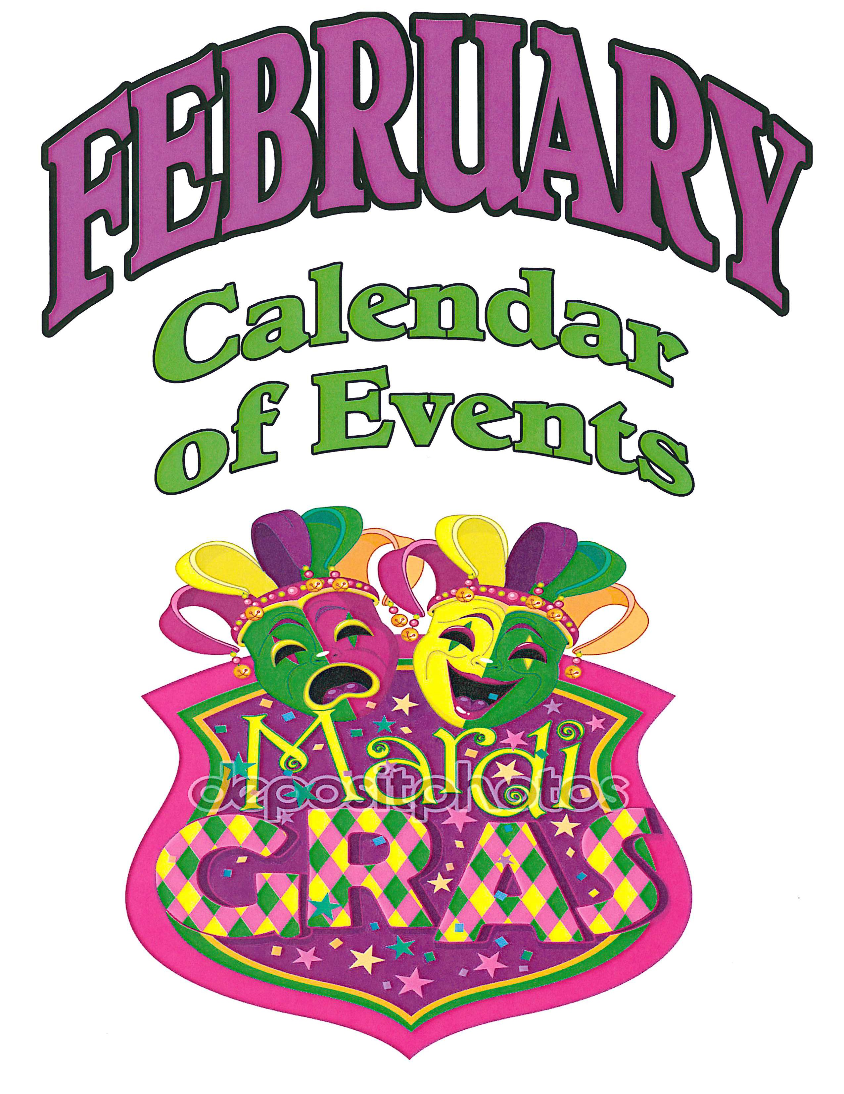

CALENDAR OF EVENTS
February 2017

Feb 1,8,15,22,29 | Zwolle | Bingo at Zwolle V.F.W. building on Hwy. 171 north. Early game starts at 6:30pm. Regular game starts at 7:00pm. 318-645-9716
Feb 4 | Toledo Bend | Tournament: Anacoco Lions Club, Cypress Bend Park, Toledo Bend Lake, Many, LA. Norman Neal 337-238-9329 or Esther Burnette 800-259-5253
Feb 4 | Toledo Bend | Tournament: Sportsman’s Bass Club, Big Bass Marina, Toledo Bend Lake, Many, LA. Open to members only. For more information, call 318-586-4721 or 337-396-0604.
Feb 4 | Toledo Bend | Tournament: Army Rec Site Monthly Bass Tournament, 1310 Army Rec Rd, Florien, LA. For more information, call 318-565-4235.
Feb 4 | Many | Live Music: Buster Jordan in Concert, Bayou Crawfish Restaurant, 650 San Antonio Ave, Many, LA. 5:30 pm-8:30 pm. For more information, call 318-431-1503.
Feb 6,13,20,27 | Zwolle | Bingo at St. Joseph's Catholic Hall on W. Hammond St. Early game starts at 6pm. Regular game starts at 7:00pm. 318-645-6098
Feb 7,14,21,28 | Toledo Bend | Bingo at D.A.V. building on Hwy. 191. Early game starts at 6:30pm. Regular game starts at 7:00pm. 318-256-6057
Feb 10-11 | Toledo Bend | Tournament: Bass Champs, Cypress Bend Park, Toledo Bend Lake,
 |  | Chad Potts 817-439-3274 or Esther Burnette 800-259-5253.
Feb 10-11 | Toledo Bend | Tournament: Southeast Region Texas Bass Nation, San Miguel Park, Ron Jones 936-615-6316 or Esther Burnette 800-259-5253
Feb 11 | Toledo Bend | Tournament: Tackle Box Open Shoot Out, Big Bass Marina, Many, LA. For more information, call 318-586-4721.
Feb 11 | Many | Art Class at the Historic Depot Museum, “Spring Flowers on a Branch”, 1-4 pm. For more information, call Kimberly Remedies 337-424-6526.
Feb 1 1 | Many | "Valentine's Day Tribute to Elvis," Many Community Center (Sabine Theater), 7pm. Fundraiser/Tickets : $10.00, 318-256-4021
Feb 17-18 | Toledo Bend | Tournament: Texas Oilfield Angels, San Miguel Park, 381 San Miguel Rd, Zwolle, LA. Chad Grubbs 903-702-8920 or Esther Burnette  800-259-5253
Feb 17-18 | Toledo Bend | Tournament: Texas Team Trail, Cypress Bend Park, 3462 Cypress Bend Dr. Many, LA. Mike Hasting 210-573-7057 or Esther Burnette 800-259-5253.
Feb 18 | Toledo Bend | Tournament: Orange Lodge #319 Bass Tournament, Pirate’s Cove Marina. For more information, call 318-565-4467.
Feb 18 | Many | Crafting Class at the Historic Depot Museum, “Bird String Art”, 1-4 pm. For more information, call Shanna Gaspard 318-602-1614.
Feb 18 | Many | 14th Annual Down & Dirty Gardening Seminar, Cypress Bend Resort, 9 am. For more information, call Maribeth Lewing 318-315-1963.
Feb 18 | Many | Movie, "Miss Peregrine's Home for Peculiar Children," Many Community Center (Sabine Theater), 7pm. FREE Admission, Concessions $1. Donations appreciated. 318-256-4021
Feb 19 | Toledo Bend | Tournament: Craig Lewis Benefit, Big Bass Marina. For more information, call 318-586-4721.
Feb 19 | Toledo Bend | Tournament: Casting for A Cause, Cypress Bend Park, Toledo Bend Lake. Russel Lewis (318) 729-0713 or Esther Burnette 800-259-5253.
Feb 25 | Toledo Bend | Tournament: Tackle Box Open Shoot Out, Big Bass Marina, Many, LA. For more information, call 318-586-4721.
Feb 25 | Toledo Bend | Tournament: Ram Weekend Bass Series, Cypress Bend Park on Toledo Bend Lake, Many, LA. Chris Wayan 256-230-5627 or Esther Burnette 800-259-5253
Feb 26 | Toledo Bend | Tournament: Bass N Bucks, San Miguel Park. For more information, call 318-645-6748.
For further information or to have events included in the monthly Calendar of Events call the author, Cheryl Ebarb, at 800-259-5253 or 318-256-4114, fax: 318-256-4179, e-mail : srala-toledo@la.gov, or www.srala-toledo.com

